Oscar Wilde: The Selfish Giant
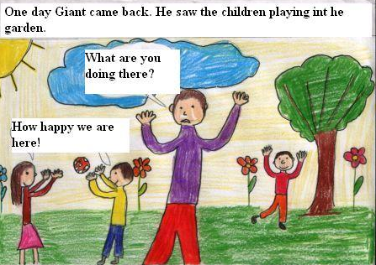
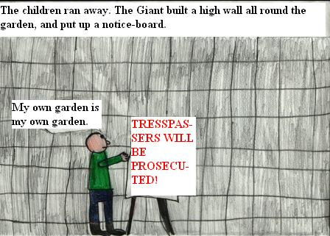
(comics)
One day the Giant came back. He saw the children playing int he garden.
The children ran away. The Giant built a high wall all round it, and put up a notice-board.
What are you doing there?  How happy we are here!  My own garden is my own garden!  Then the Sprong came. Only in the garden of the Selfish Giant it was still winter. | The Snow covered up the grass with her great white cloak, and the Frost painted all the trees silver.
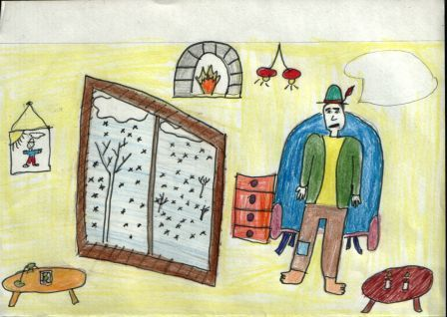  Spring has forgotten this garden! | 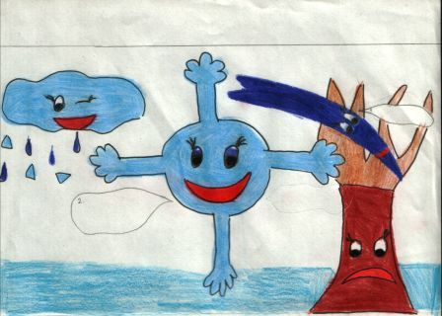  This is a delightful spot!  Hur-ray!
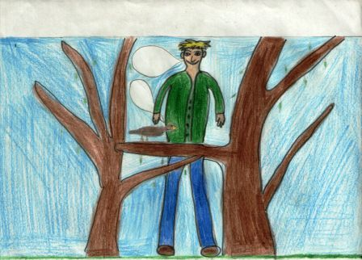  I believe the Spring has come at last!  One morning the Giant heard some lovely music. Only a little linnet singing outside his window.  Through a little hole int he wall the children had crept in. The trees were so glad again that they had covered themselves with blossoms.  Only in one corner it was still winter. In it was standing a little boy. He was so small that he could not reach up to the branches of the tree. | 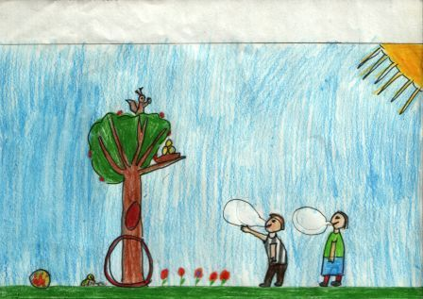  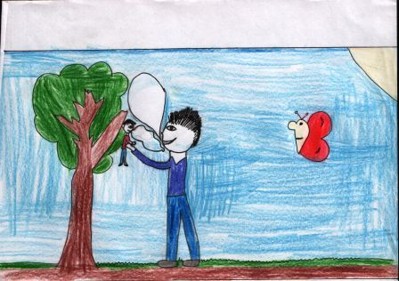  How happy we are here!  Yes!  The Giant stole up behind him and took him gently in his hand, and put him up into the tree.
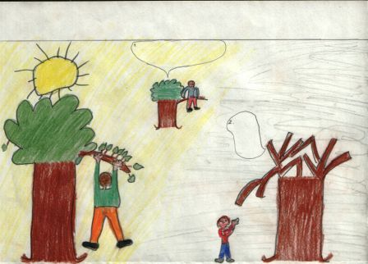  Climb up! little boy  How happy we are here! | Come on! Don’t worry!
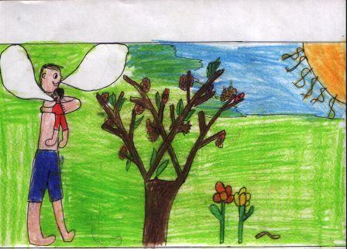  Come on!  Thenk you!  The little boy strtched out his two arms and flung them round the Giant’s neck, and kissed him.  The other children, when they saw that the Giant was not wicked any longer, came running back, and with them came the Spring. | 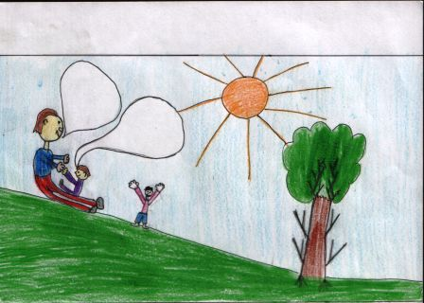  It is your garden now!  Hurray!
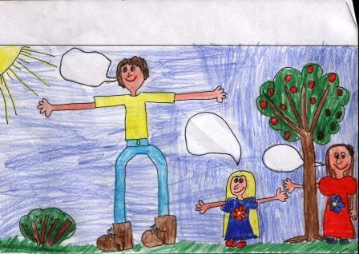  How I would like to see him!  We don’t know.  He has gone away.  I have many beautiful flowers, buth the children are the most beautiful flowers of all.  Every afternoon, when school was over, the children came and played with the giant. But the little boy whom the Giant loved was never seen again.  Years went over, and the Giant grew very old and feeble. He could not play about any more, he is only admired his garden. | 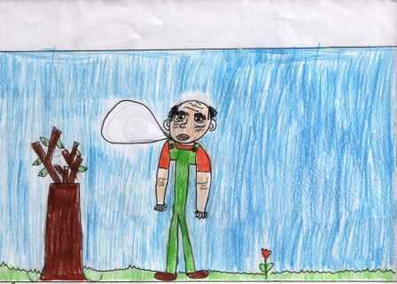
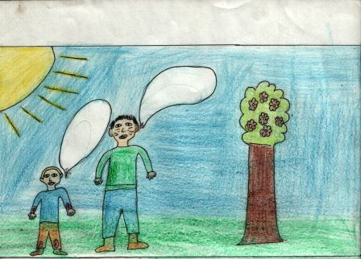  Who hath dared to wound thee?  Nay! But these are the wounds of Love.  One morning int he farthest corner of the garden was a tree quite covered with lovely vhite blossoms. Underneath it stood the little boy he had loved.  A strange awe fell ont he Giant, and he knelt before the little child. | 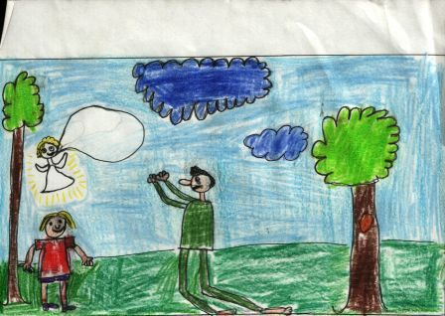  Who art thou?  Come with me to my garden, which is Paradise!
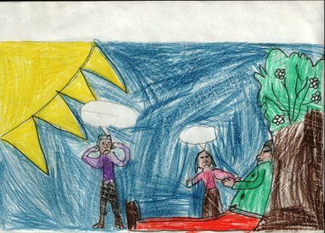
No!
Oh, my God! The Giant died!
When the children ran int hat afternoon, they found the Giant lying dead under the tree.

